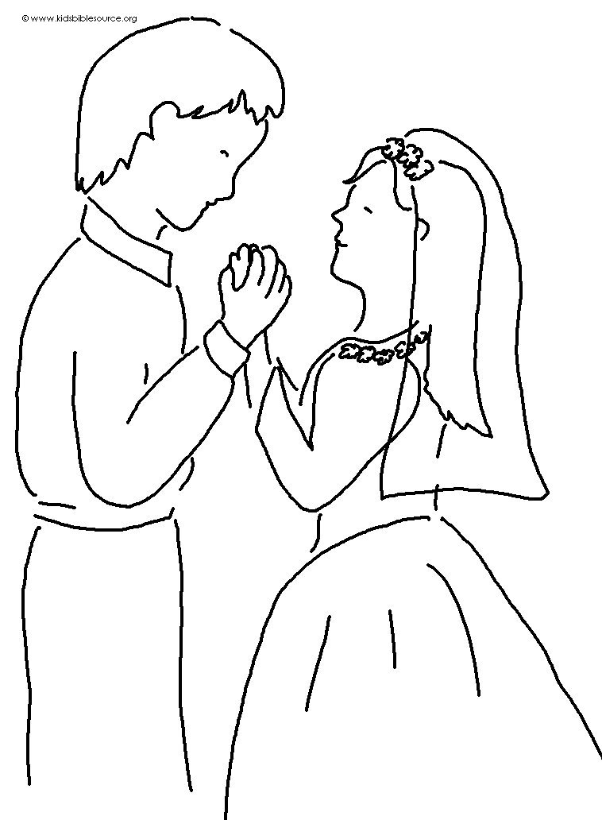
The Lord says,
"I will guide you."
Psalm 32:8 _{NLT}

